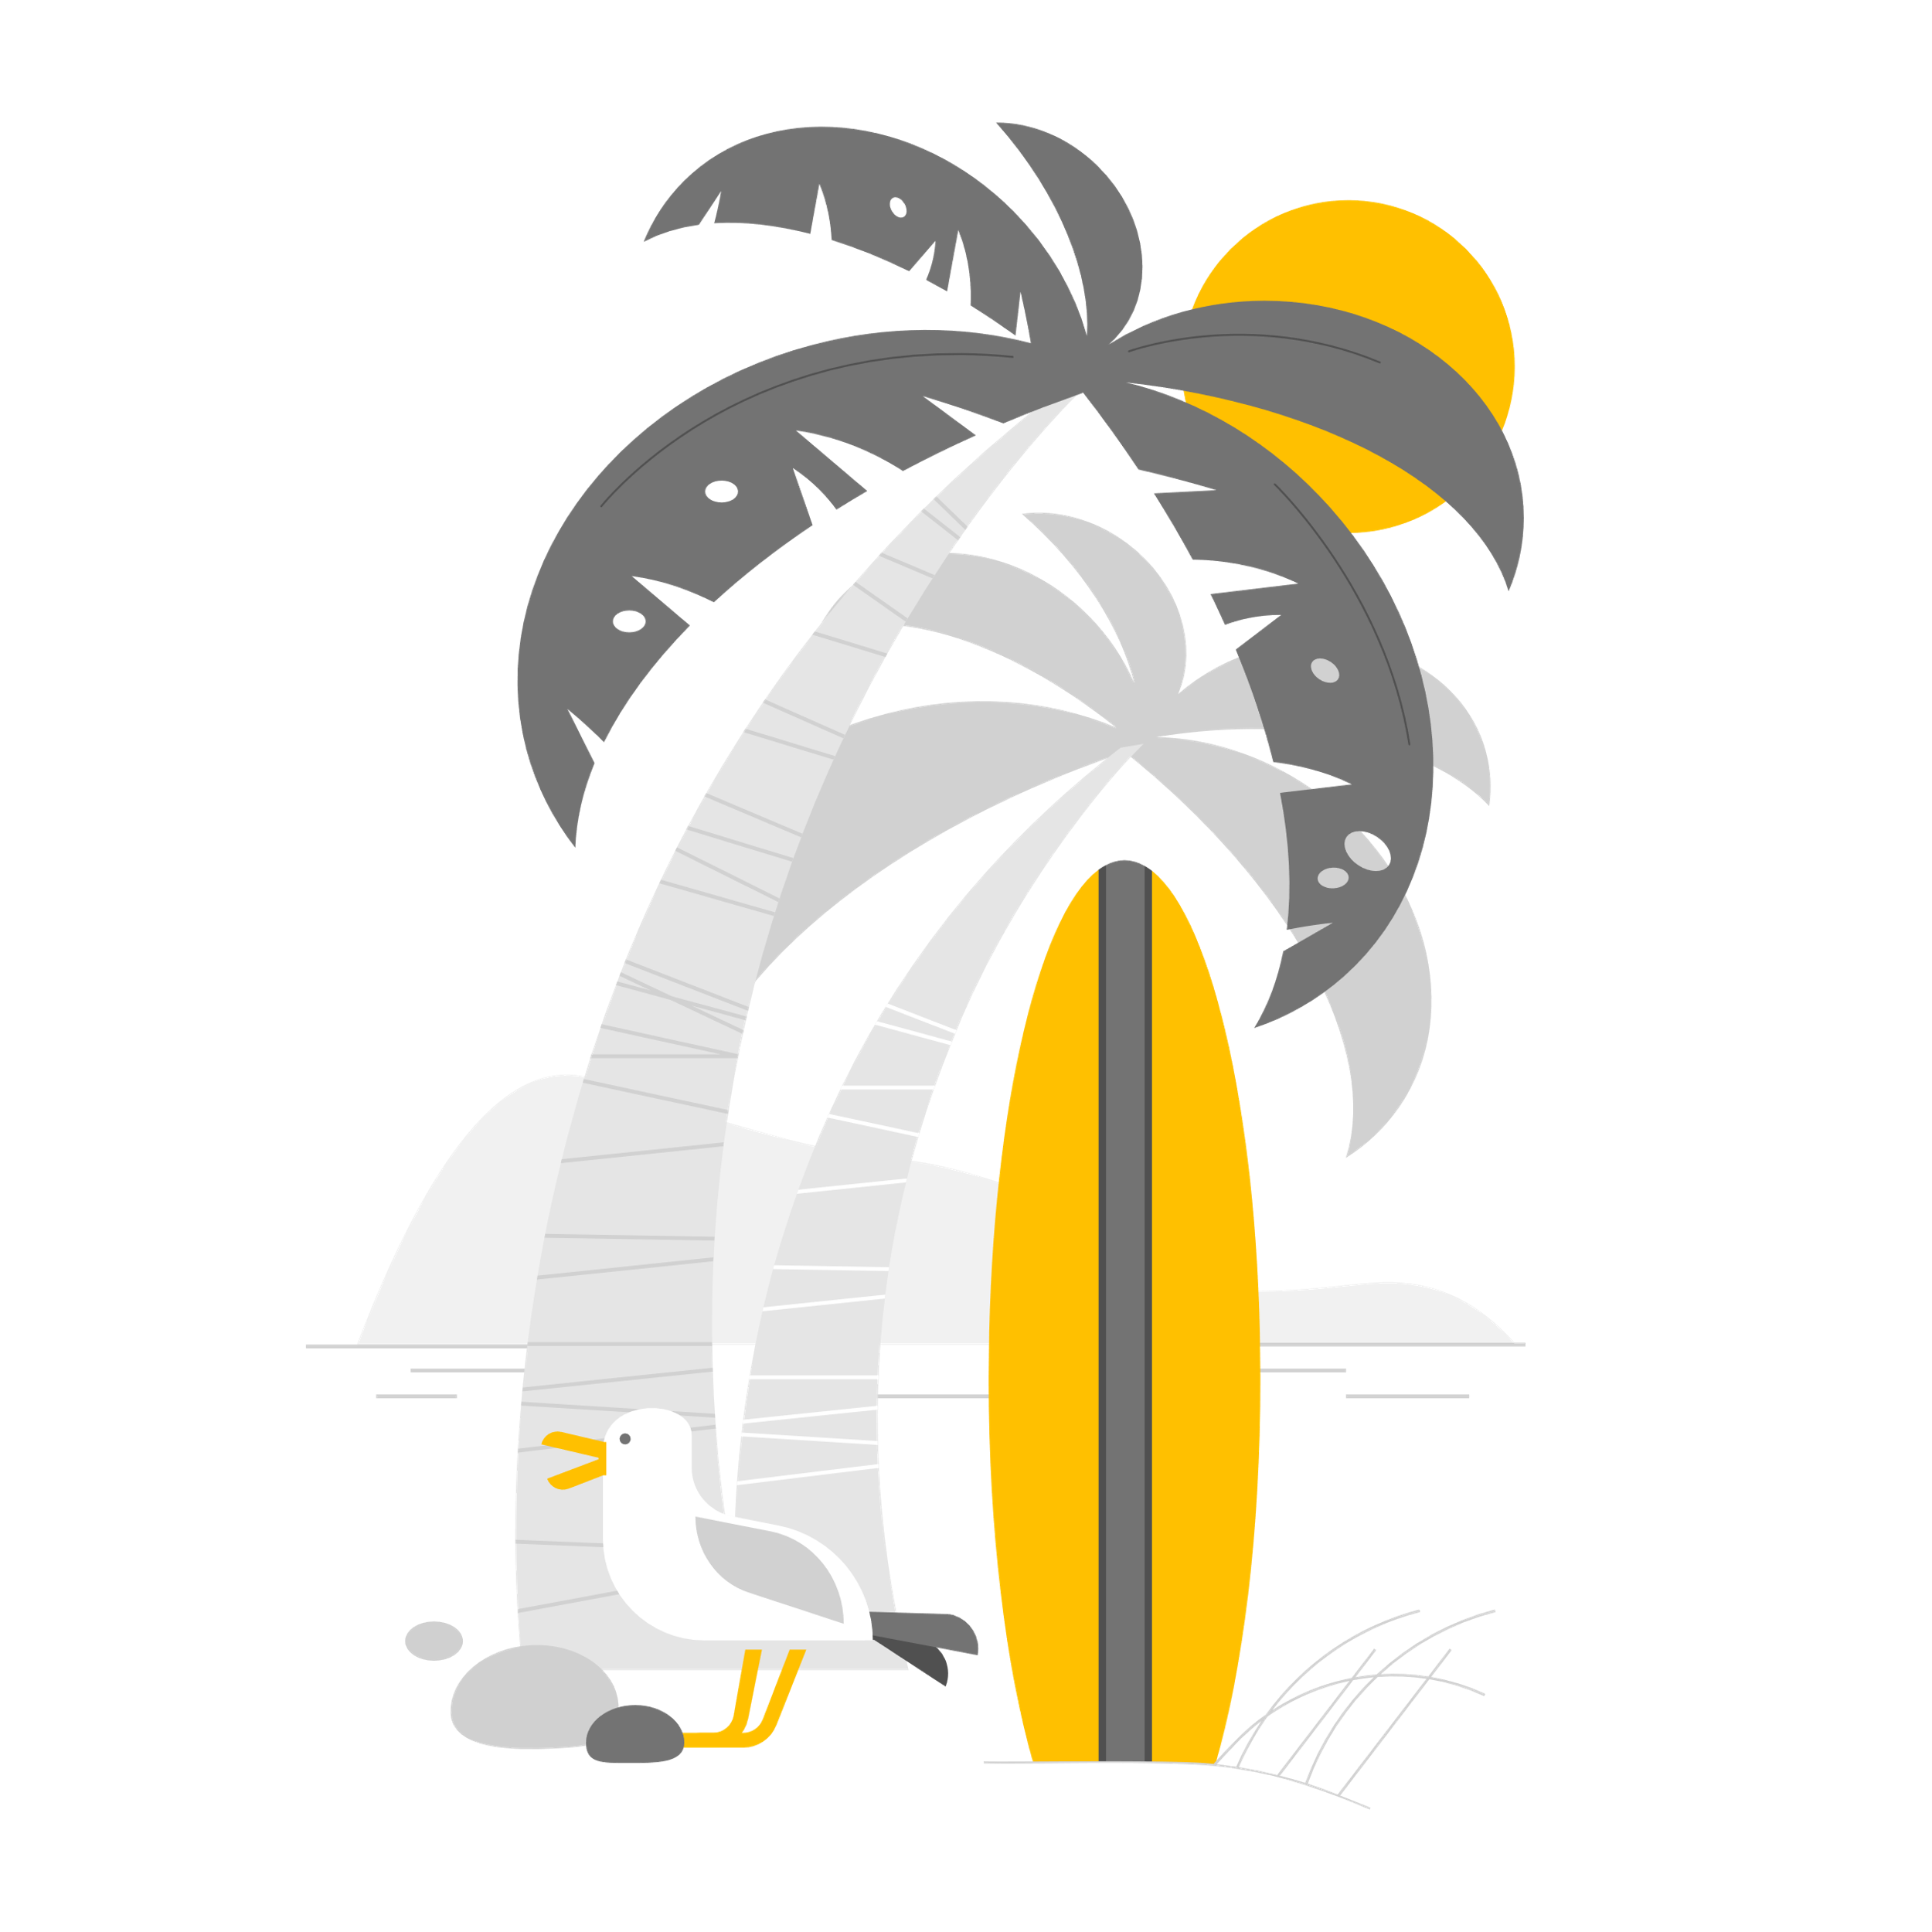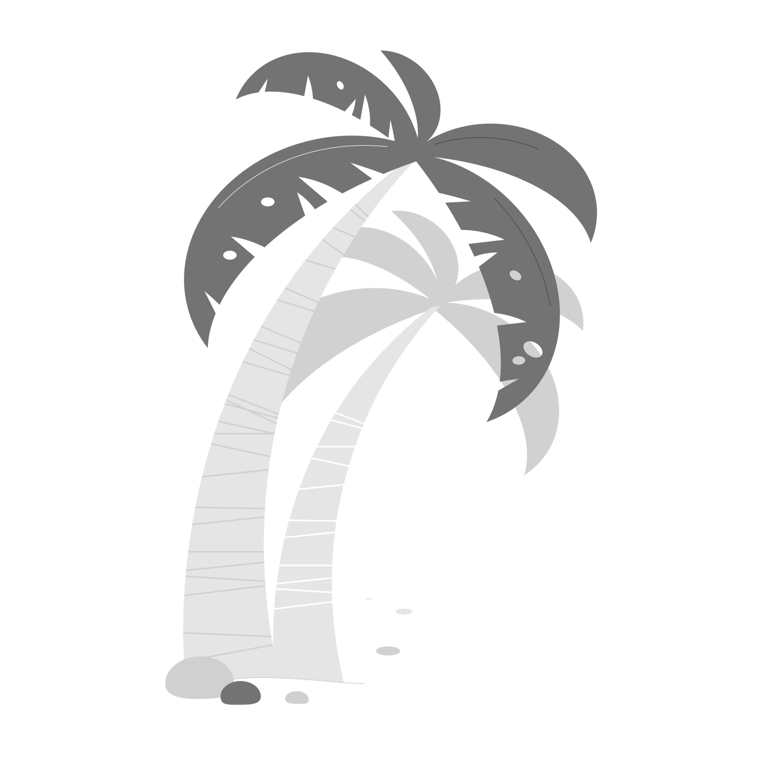

Dear Canyon Families,

Welcome to the Canyon Library Program for the 2023/2024 school year. Your child may be visiting the library once or twice in the six-day rotation, depending on their schedule. Jr. high will come to the library for book checkout only. The books your child checks out are due back to the library the following scheduled library class. Students will only be permitted to check out a new book if their books are returned. If they forget their library books, they will not be allowed to check out another one until the previous one is returned. The joy of sharing books is a special gift you can give your child, so be sure to read with your child the books they have selected and keep them in their backpack. Kindergarten through second grade will be allowed to check out one book at a time. Third through eighth grade will be allowed to check out two at a time.

If the books are lost or damaged, parents/guardians are responsible for paying the replacement cost of the book(s). These are not new policies but rather a reminder of the Policies and Procedures for checking out library books.

I look forward to reading many wonderful stories, teaching new library concepts, and seeing them develop a love for books and reading. Please email Mrs. Lenocker at [klenocker@pusd11.net](mailto:klenocker@pusd11.net) with any questions.

By signing below, you acknowledge that you have read the above information and understand that you and your child are responsible for the books that they check out. Once this is signed and returned your student will be able to check out library books.

Student Name________________________ Grade_______ Teacher_____________

________________________________________________________________________ Parent/Guardian Signature Date